NAME : KAFLE SAMRAT

201801060933

软件工程2018-1班

1. IN nested queries

Check the total amount of an order with customer No. 1 and Order No. 2

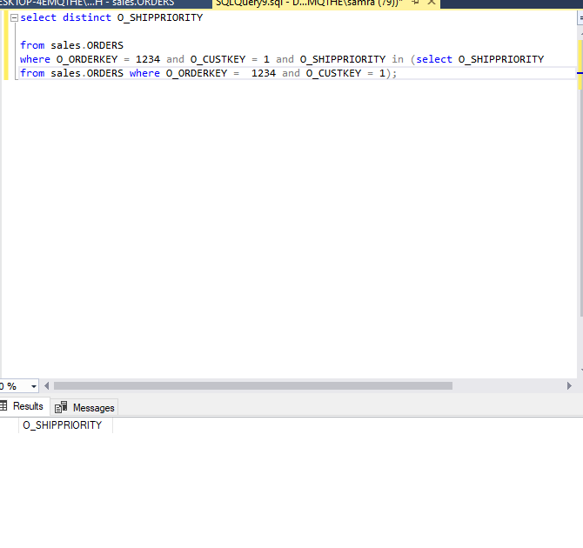

2）EXISTS (NOTEXISTS) nested queries

Check the total amount of an order with customer No. 1 and Order No. 2

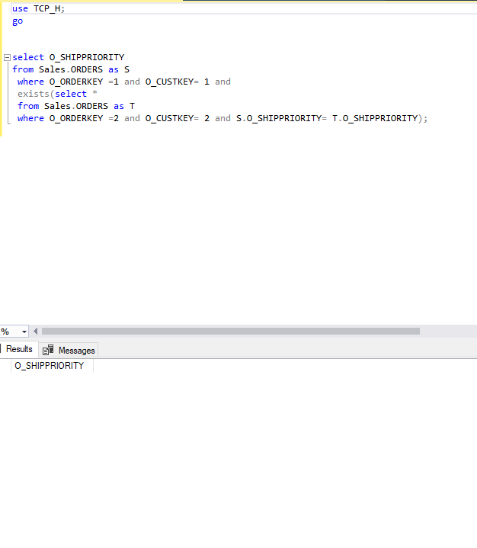

3）Nested queries (derived queries) in the FROM clause

Query the total amount of an order greater than 20 and its bookkeeper

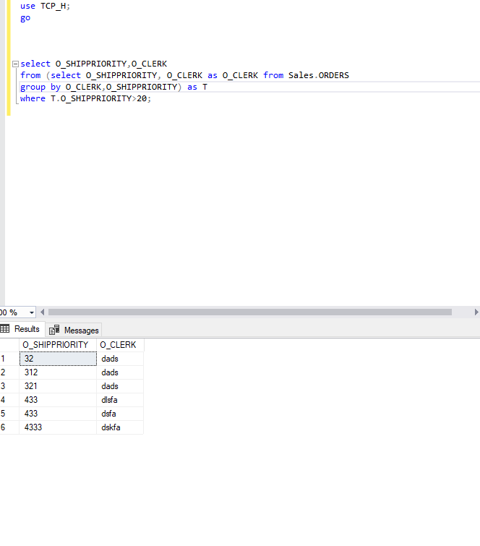

4）Set the query

Enquire order No. The total amount of an order with customer No. 1 and Order No. 2 or both cases where the total amount is the same

